TASK 1

A To-Do List application is a useful project that helps users manage and organize their tasks efficiently. This project aims to create a command-line or GUI-based application using Python, allowing users to create, update, and track their to-do lists

CODE:

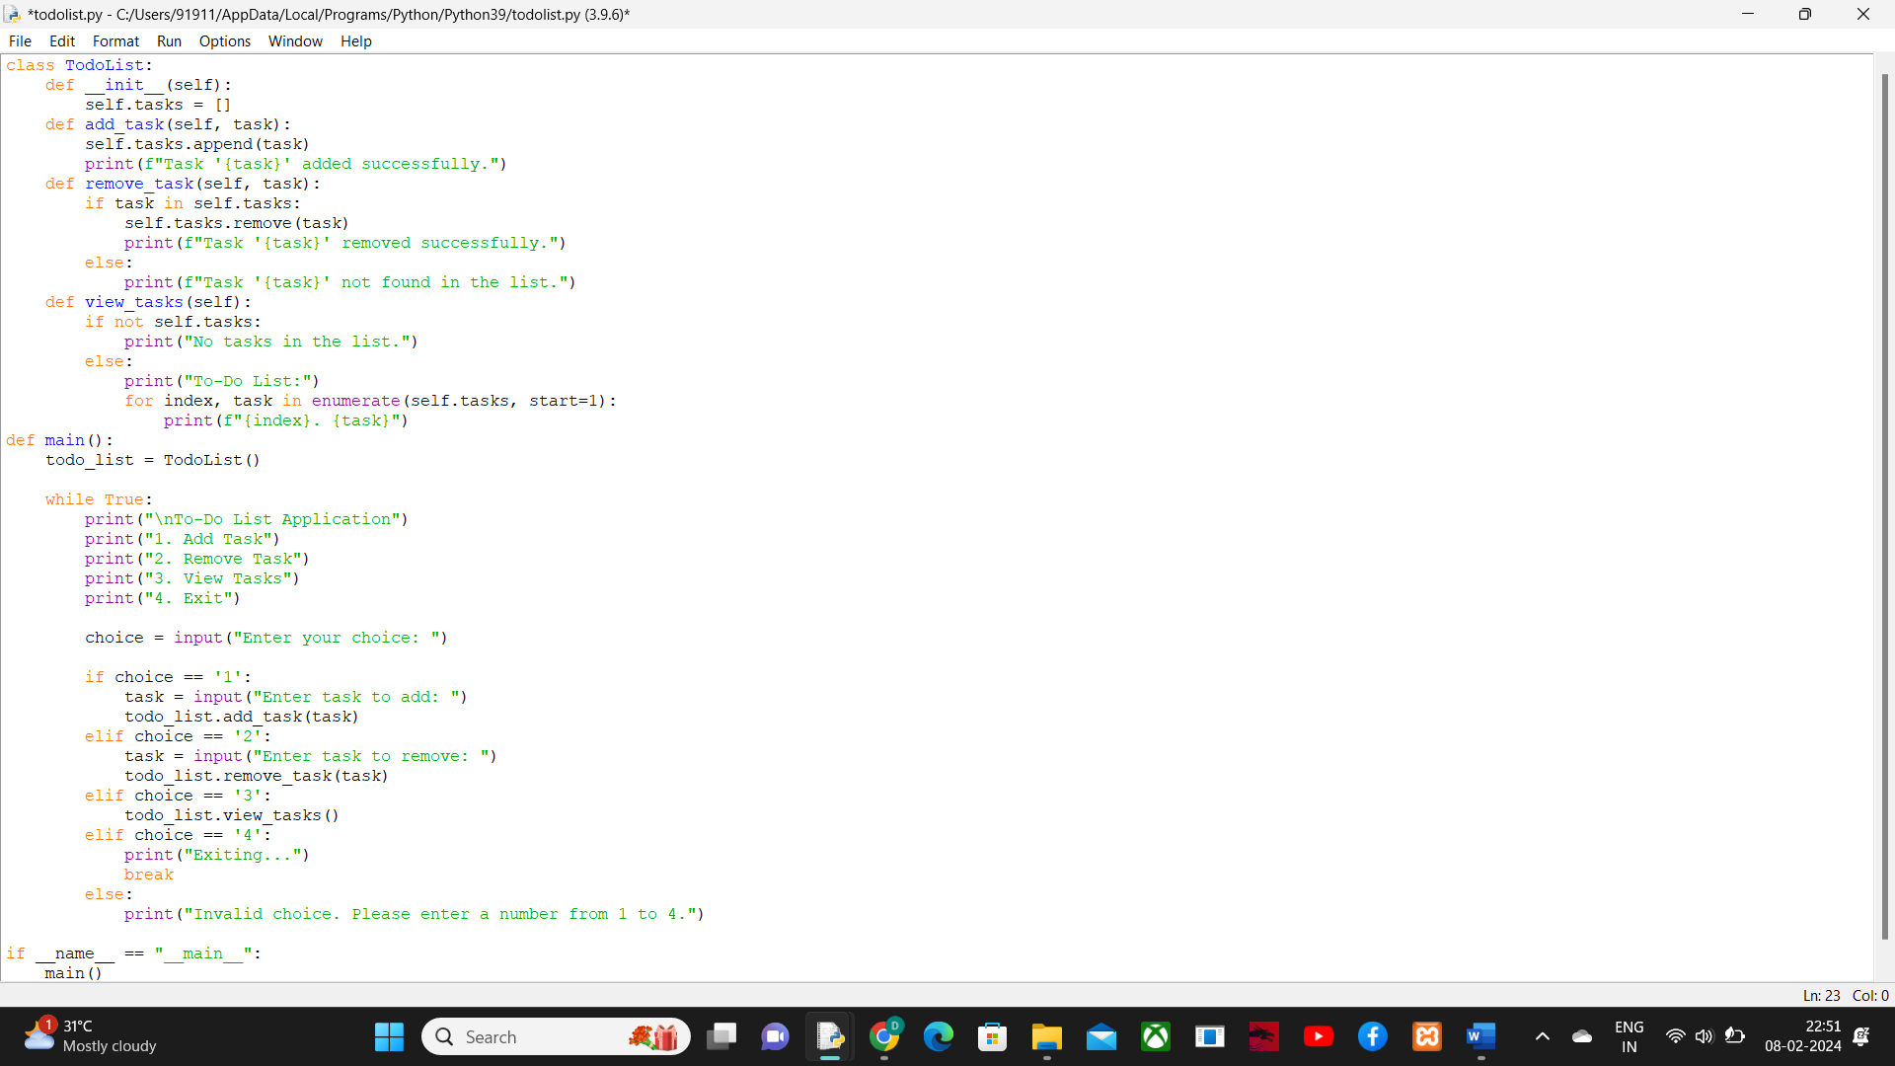

OUTPUT:

